Reed College, Portland OR
Quantum Mechanics Experiments with Individual Photons
Dates: May 27, 2020 to May 29, 2020
Number of setups available: 2
Maximum number of participants: 4
------------------------------------------------------------------------------------------------------------------------------------------
1. Overview
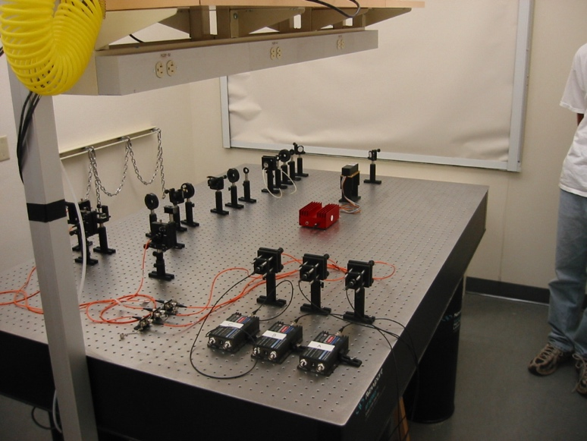
In this immersion participants will learn to perform advanced undergraduate laboratory experiments that explore modern aspects of quantum mechanics. The laboratories all involve studying the behavior of single photons and correlated photon pairs, and include experiments on "proving" that light contains photons, single-photon interference, and tests of local realism. Additionally, the immersion will contain discussions of the physics behind these experiments, and how they can be integrated with a junior/senior level quantum mechanics course.

2. Apparatus
The light source for all of the experiments uses a blue diode laser to pump a nonlinear crystal, which produces photon pairs via spontaneous parametric down conversion. The photons are coupled into optical fibers, detected with single photon counting modules, and the photo-count data is processed with an FPGA-based coincidence counting unit. Final data acquisition and analysis is performed on a PC using LabView. Participants will become familiar with all aspects of the apparatus, especially the optical alignment. All equipment necessary to perform these experiments (including laser safety equipment) will be provided. Participants should bring a copy of Quantum Mechanics: Theory and Experiment, by Mark Beck (Oxford Univ. Press, 2012) to the immersion, as the laboratories we will perform are described there. It would also be helpful for participants to have read through the presentation of these laboratories in the text prior to arriving at the immersion, but that is not essential.

3. Schedule

Day-1, Morning
- Initial alignment
- Properties of spontaneous parametric down conversion

Day-1, Afternoon
- "Proving" that light consists of photons: The Grangier experiment

Day-2, Morning
- Alignment of the polarization interferometer

Day-2, Afternoon
- Single-photon interference
- The quantum eraser

Day-3, Morning
- Alignment of the two-crystal source
- Properties of polarization-entangled photons

Day-3, Afternoon
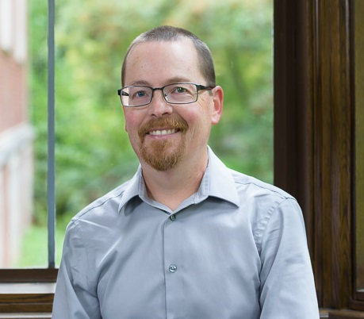
- Tests of local realism (Bell-CHSH, Hardy)

During each session there will be time devoted to discussing the theory underpinning the experiments, as well as suggestions for integrating the experiments with a quantum mechanics course. For more information on the experiments, including a recent parts list, please visit http://www.reed.edu/~beckm/QM/ . The approximate cost for implementing the experiments is $20,000.

Mentors: Mark Beck
Mark Beck obtained his BS and PhD degrees in Optics from the University of Rochester. He was a postdoctoral researcher at the University of Oregon, and has taught physics at Reed College and Whitman College since 1994. His areas of research specialization are quantum optics and quantum measurement. He has worked on developing new undergraduate quantum mechanics teaching laboratories, as well as developing instrumentation and techniques for making these laboratories accessible to a wide range of institutions. He is the author of “Quantum Mechanics: Theory and Experiment” (Oxford University Press, 2012), and the recipient of the 2018 Richtmyer Memorial Lecture Award from the AAPT.

