4th Conference on Physics Laboratory Instruction
Beyond the First Year of College (BFY 4)
CSU Chico, Chico, CA
July 12-14, 2023

As a vendor of equipment that can be useful for advanced physics laboratory instruction, you are invited to participate in a unique topical conference that we believe will be very productive for you. Between July 12-14 of this year, we will hold our first in-person conference on laboratory instruction for Faculty and Staff involved in the delivery of physics laboratories beyond the first-year of college since 2018. These labs are often referred to as advanced physics laboratories. Details of previous conferences are found at https://advlab.org/meetings.

Your participation as a vendor will be quite different from your experiences at other conferences. Instead of the usual trade show, you will be an integral part of the conference itself. Over the course of two days, we have blocked off a total of 8 hours where all participants will participate in 40-minute-long, hands-on, small group workshops. As a participating vendor, you will have a chance to showcase your equipment by using it in an experiment that is or could be used in advanced laboratory instruction. You will work with 12 groups during the workshop time. We have a subcommittee set up to work with you, to address any questions you may have about this particular audience, and to provide examples of previous workshops and feedback on workshop ideas you might have. We can assure you that, unlike the casual traffic you see at a normal trade show or scientific conference, the participants attending your workshop will have a very focused interest in your products because of the way we schedule participants into particular workshops. We will try to schedule as many interested people as we can for your workshop.

In addition, at the end of the conference (roughly 1:00-3:30 pm on Friday) and during breaks throughout the conference, you will have the opportunity to engage informally with participants, who will be encouraged to explore vendor workshops they did not attend or to obtain additional information or to get more hands-on experience with equipment that they used during a workshop. These workshops and other engagement opportunities will take place in the teaching labs at CSU Chico in an environment ideally suited to demonstrating how your products can be used in an instructional lab setting. Vendors have found this type of engagement with laboratory instructors very beneficial at prior conferences.

We wish to offer you some degree of flexibility in how you might take advantage of this opportunity. For example, you might consider offering one type of workshop experiment on the first day of the conference and another on the second day. Or you may want to bring additional people to offer more than one workshop during each 40-minute session. The extensive laboratory space available at Cal State Chico will allow us to provide additional table space for each additional workshop offered in a 40-minute session. We are holding vendor registration flat from BFY3 at $900 for each table, due by June 1, 2023. This covers conference registration for your representatives/workshop leaders, a table for your workshop equipment in a secure lab room, and acknowledgement in the conference program, on the conference website, and via social media. Vendor registration is open at: https://advlab.org/event-5213611.

As a vendor and conference participant you are invited to attend the plenary sessions, small group breakout sessions, and poster sessions, as well as the meals and coffee breaks during the conference. You would also have the opportunity to contribute a poster during the poster session so that participants can learn more about your products and how they might be used in an advanced lab setting.

If you decide to participate, we encourage you help sponsor a meal or a coffee break through an sponsorship donation as well, if possible. We will acknowledge your contribution prominently at that food event, in the printed conference materials, through social media, and also on the website with a direct link from the conference website to your company’s website. Information on sponsorship opportunities can be found on the following page.

The highly directed nature of our workshop structure ensures that this will be a very productive opportunity for you even though the format of our conference involves fewer total participants than some of the other conferences you attend. At each of our previous conferences, we have had 130-150 participants who are directly involved in teaching advanced labs at over 100 colleges and universities, R1 to 4-year liberal arts colleges, plus a few 2-year technical colleges that have special offerings. Importantly, many of the participants have direct authority over (or significant input into) equipment purchases for their advanced laboratory courses. At the conclusion of the conference, we will provide you with names and email addresses of all participants who do not opt out of sharing this information.

For additional information, please contact
Dr. Joe Kozminski (kozminjo@lewisu.edu, 815-836-5393) or Dr. Daniel Borrero (dborrero@willamette.edu, 503-370-6753).

We look forward to seeing you at BFY4!

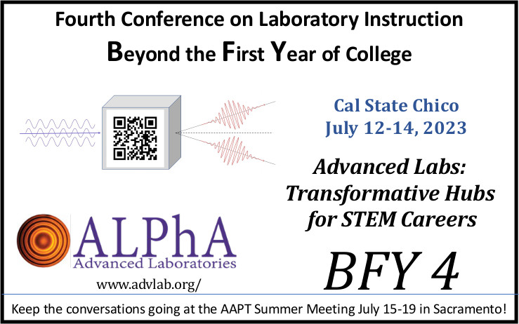

Fourth Conference on Laboratory Instruction
Beyond The First Year
(BFY4)
California State University Chico, Chico, CA
July 12-14, 2023

Registration Information
Registration fee per table  Includes:  - Conference registration for exhibitors  - Lab table for an experimental set-up  - 8 hours of workshop time to interact with 12 small groups of participants  - Opportunities to interact informally with participants during coffee breaks Wednesday and Thursday and Friday afternoon  - Acknowledgment in the program  - Acknowledgement on social media during the conference | $900

Sponsorship Information
Food Events | Primary Sponsorship | Partial Sponsorship
(1) Poster Meal | $4,000.00 | $2,000.00
(2) Lunches | $2,500.00 | $1000.00
(1) Breakfast | $1,500.00 | $750.00
(3) Morning or (2) Afternoon Breaks | $500.00 | $250.00

We encourage each vendor to be a primary or partial sponsor at a food event. While the sponsorship funds will be used to support the conference in general, we will provide a banner recognizing the sponsor at the specified event. Sponsors will receive additional recognition in the program and on the website. Sponsors will also receive additional acknowledgement before, during, and after the BFY4 conference on social media.
Wednesday dinner is on-your-own in town, so vendors might consider hosting a table of attendees for dinner. We will acknowledge those who sponsor a table at dinner, and we can provide a list of restaurants that CSU Chico partners with and can help you with a reservation and sign up if you would like. However, there is not a sponsorship level through ALPhA for this.
Contact Joe Kozminski (kozminjo@lewisu.edu) or Daniel Borrero Echeverry (dborrero@willamette.edu) for more information. Register and secure your spot at: https://advlab.org/event-5213611

